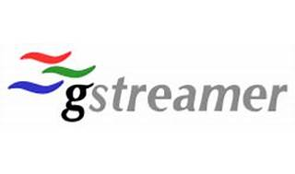



Explore

**GStreamer** is a **pipeline-based multimedia framework** that connects various media processing systems, allowing complex workflows. It enables building systems to read files in one format, process them, and export them in another, with plug-and-play flexibility. [GStreamer supports tasks like audio/video playback, recording, streaming, and editing, making it a versatile tool for multimedia applications1](https://en.wikipedia.org/wiki/GStreamer)[2](https://gstreamer.freedesktop.org/documentation/application-development/introduction/gstreamer.html).

Here are **five free reference links** where you can learn more about GStreamer:

1. [**GStreamer Wikipedia**](https://en.wikipedia.org/wiki/GStreamer): Provides detailed information about GStreamer’s architecture, components, and usage.
2. [**GStreamer Documentation**](https://gstreamer.freedesktop.org/documentation/application-development/introduction/gstreamer.html): Offers an introduction to GStreamer, including its API, plugin architecture, and multimedia application development.
3. [**Medium Article: Introduction to GStreamer**](https://medium.com/@areadarsh/introduction-to-gstreamer-777045dd9c7a): Explains GStreamer’s role in creating media players, transcoding tools, and streaming servers.
4. **GStreamer Official Website**: The official site with resources, documentation, and community support.
5. **GStreamer on GitLab**: Access the source code, contribute, and explore GStreamer’s development.

Happy learning! 🎥🎵📺